**Classroom Activity: Create a simple React application that takes data from a user through a form and displays it.**

**Step 1:**

Create a new React application using the following command in vs code terminal.

* npx create-react-app form-demo-app
* cd form-demo-app

**Step 2:**

Create a **components** directory and **FormComponent.js** to Fetch and Display Data.

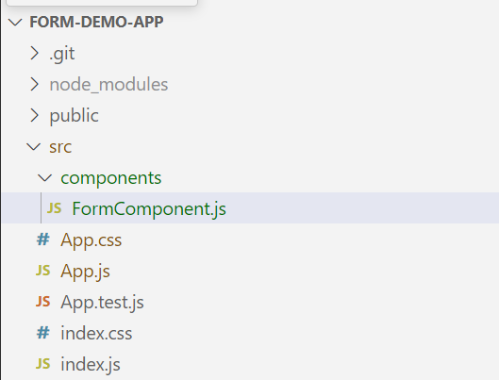

Figure: Program Structure’s Screenshot

**Code:**

File Name: src/components/ FormComponent.js

|  |
| --- |
| import React, { useState } from 'react';  const FormComponent = () => {    const [formData, setFormData] = useState({      name: '',      email: '',      age: ''    });    const [submittedData, setSubmittedData] = useState(null);    const handleChange = (e) => {      const { name, value } = e.target;      setFormData({        ...formData,        [name]: value      });    };    const handleSubmit = (e) => {      e.preventDefault();      setSubmittedData(formData);    };    return (      <div className="form-container">        <form onSubmit={handleSubmit}>          <div className="form-group">            <label>Name:</label>            <input              type="text"              name="name"              value={formData.name}              onChange={handleChange}            />          </div>          <div className="form-group">            <label>Email:</label>            <input              type="email"              name="email"              value={formData.email}              onChange={handleChange}            />          </div>          <div className="form-group">            <label>Age:</label>            <input              type="number"              name="age"              value={formData.age}              onChange={handleChange}            />          </div>          <button type="submit">Submit</button>        </form>        {submittedData && (          <div className="submitted-data">            <h2>Submitted Data</h2>            <p><strong>Name:</strong> {submittedData.name}</p>            <p><strong>Email:</strong> {submittedData.email}</p>            <p><strong>Age:</strong> {submittedData.age}</p>          </div>        )}      </div>    );  };  export default FormComponent; |

File Name: src/App.js

|  |
| --- |
| import './App.css';  import FormComponent from './components/FormComponent';  function App() {    return (      <div className="App">        <h1>User Data Form</h1>        <FormComponent />      </div>    );  }  export default App; |

File Name: src/App.css

|  |
| --- |
| /* src/App.css */  .App {    text-align: center;    padding: 20px;  }  .form-container {    max-width: 400px;    margin: 0 auto;  }  form {    margin: 20px auto;    padding: 20px;    border: 1px solid #ccc;    border-radius: 10px;    background-color: #f9f9f9;  }  .form-group {    margin-bottom: 15px;  }  label {    display: block;    margin-bottom: 5px;  }  input {    width: 100%;    padding: 8px;    box-sizing: border-box;  }  button {    padding: 10px 20px;    background-color: #4CAF50;    color: white;    border: none;    border-radius: 5px;    cursor: pointer;  }  button:hover {    background-color: #45a049;  }  .submitted-data {    margin-top: 20px;    padding: 20px;    border: 1px solid #ccc;    border-radius: 10px;    background-color: #e9e9e9;  }  .submitted-data h2 {    margin-top: 0;  }  .submitted-data p {    margin: 5px 0;    font-size: 16px;  }  .submitted-data p strong {    color: #333;  } |

**OUTPUT:**

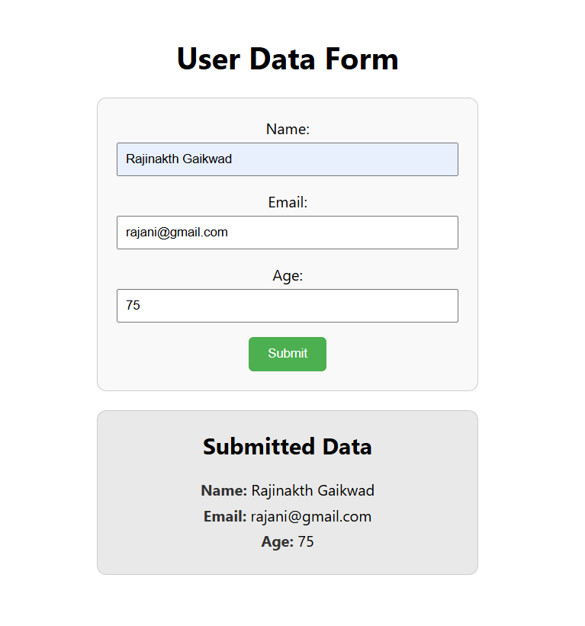

Figure: Output Screenshot

**Execution Steps:**

* Go to VS Code terminal
* Execute the following command to run the program:
* npm start
* This will open your default browser and navigate to http://localhost:3000, where you will see your new React application running.